Lab 5- Generating and Reviewing a Query Plan

Estimated completion time
- 20 minutes

Learning objectives
In this lab, students will:
- Generate a query plan in Starburst.
- Learn how to interpret the different stages of the plan.
- Identify potential performance bottlenecks.

Prerequisites
- Lab 1: Access your lab environment

Activities
- Generate a query plan
- Review query plan output
- Hands-on Challenge

What is a query plan?
When you run a SQL query in Starburst, the engine first creates a query plan — a step-by-step roadmap of how the query will be executed. Reviewing a query plan helps analysts understand performance and validate that queries are written efficiently.

Step 1: Generate a query plan
- Rather than executing a query, use EXPLAIN to view the query plan first:

EXPLAIN
SELECT
c.customer_id,
c.customer_name,
SUM(ev.usage_hours) AS total_usage
FROM crm.customers c
JOIN usage.events ev
ON c.customer_id = ev.customer_id
WHERE ev.event_date >= current_date - INTERVAL '90' DAY
GROUP BY c.customer_id, c.customer_name
ORDER BY total_usage DESC
LIMIT 10;

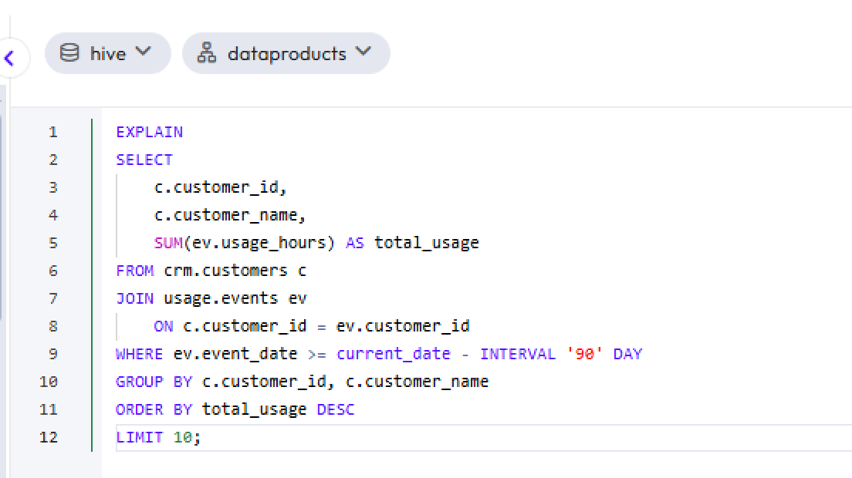

Step 2: Review query plan output
Images of the full query plan generated in the previous step are provided below. Look for the following sections, which have been color-coded in the images:

- Scan Nodes → Show which tables are being read.
- Filter/Projection → Show how filters (WHERE) and column selections are applied.
- Join → Show join strategies (e.g., hash join, broadcast join).
- Aggregation → Show how sums, counts, or averages are calculated.
- Exchange → Show where data is shuffled between worker nodes.

💡 Query plans are read from the bottom up! Therefore, in this instance, you should scroll down and begin by reading Fragment 3.

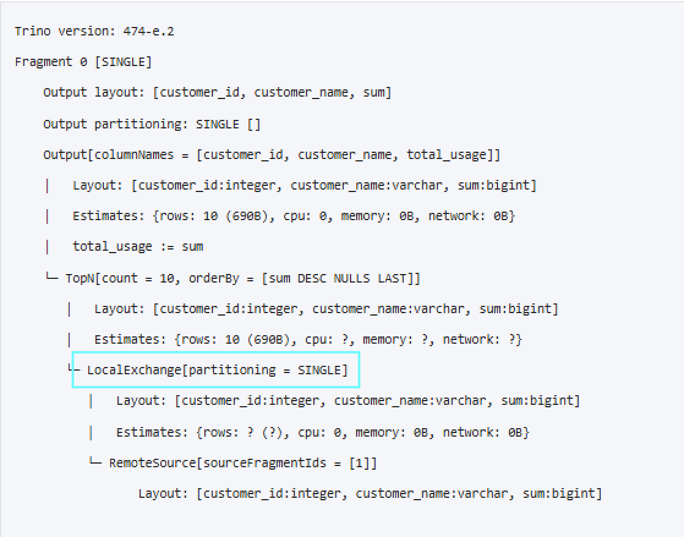
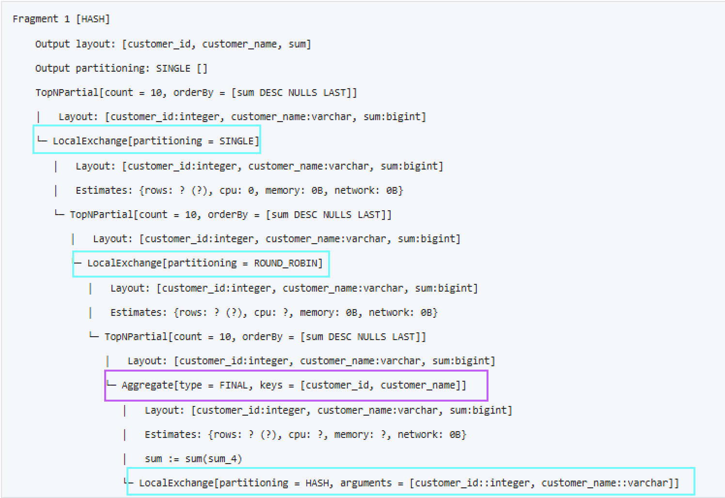
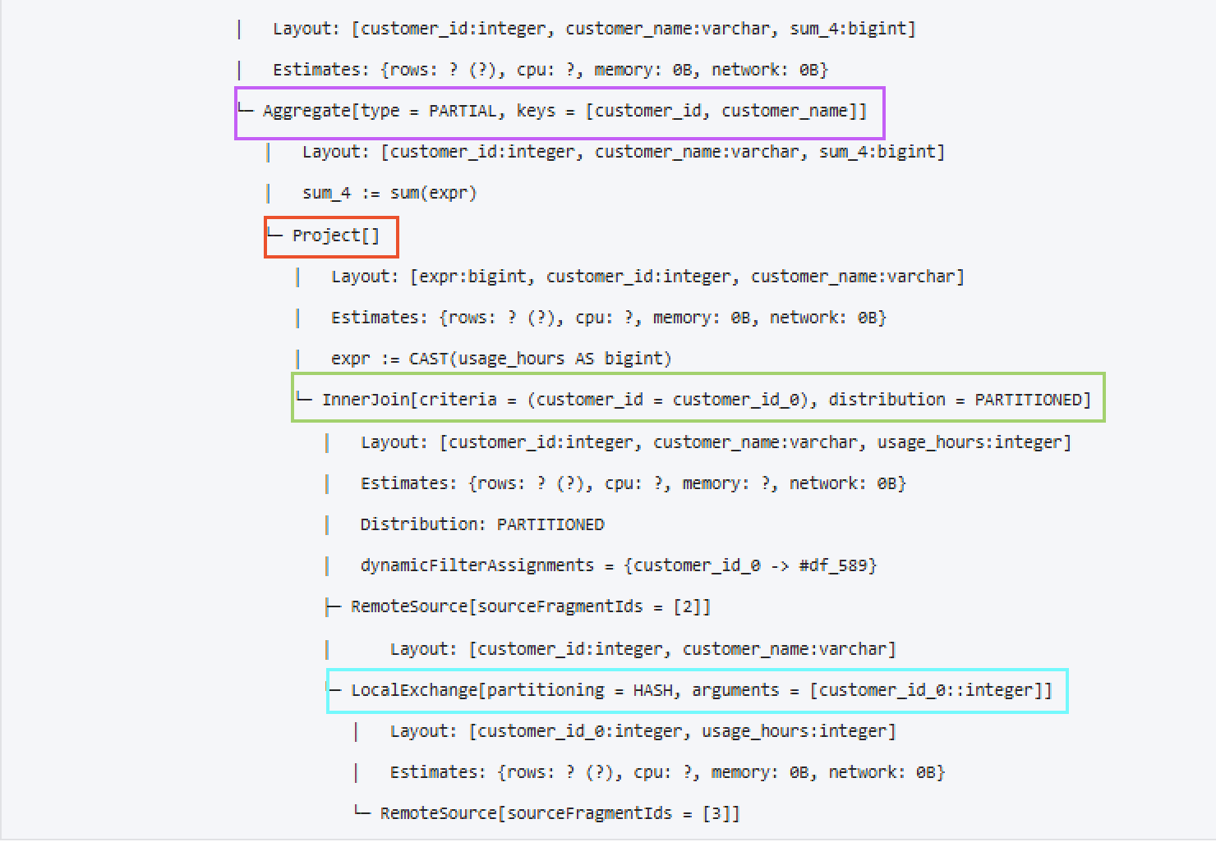
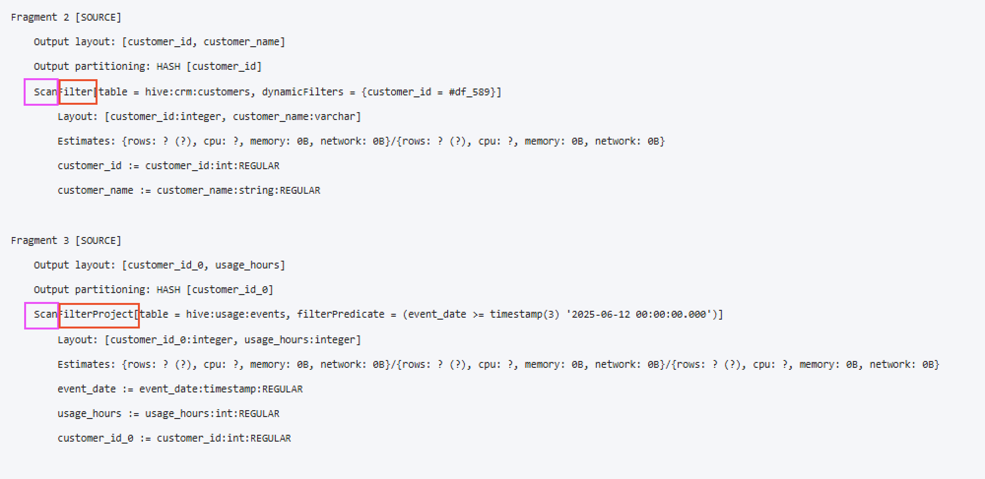

Step 3: Hands-On Challenge
Run the following SQL and review the resulting query plan:
EXPLAIN (TYPE DISTRIBUTED)
SELECT
s.campaign_id,
c.campaign_name,
COUNT(s.order_id) AS num_orders,
SUM(s.order_total) AS total_sales
FROM bootcamp.sales_db.sales_orders s
JOIN iceberg.marketing_data.campaigns c
ON s.campaign_id = c.campaign_id
GROUP BY s.campaign_id, c.campaign_name
ORDER BY total_sales DESC;

Questions to Consider:
- Which tables are being scanned?
- What type of join is used?
- Where are aggregations performed?
- Do you see any “Exchange” steps that indicate data movement across nodes?

Example Plan Breakdown
The exact output may vary depending on your cluster setup, but you should look for the following elements as you review the query plan output.

Table Scan
Two scans will appear:
- sales_orders (scanning order_id, order_total, campaign_id)
- campaigns (scanning campaign_id, campaign_name)
👉Notice that only the necessary columns are scanned.

Join Node
- A hash join is used on campaign_id.
- Depending on table sizes, Starburst may choose a broadcast join (replicating the smaller table across workers).
👉 campaigns is the likely broadcast table because it’s much smaller than sales_orders.
Aggregation Nodes
COUNT(order_id) and SUM(order_total) are grouped by campaign_id, campaign_name.
👉 This step reduces data volume by aggregating before sorting.

Exchange Nodes
- Appear when data is shuffled between workers to complete joins or aggregations.
- Look for lines labeled Exchange — these usually indicate network overhead.
👉 Shuffles are expensive. How could we minimize them? (e.g., partitioning, filtering earlier).

Order By
- Sorting by total_sales DESC happens last.
- Sorting is also resource-intensive, especially on large datasets.

END OF LAB EXERCISE

